

**Executive Board**

* **Mayo**

Dr. Bruce Sutor *

Dr. Casey Clements * (Vice Chair)

Erin Sexton **

Clare Larsen

Wendy Moore

* **Olmsted Medical Center**

Dr. James Hoffmann *

* **Olmsted County**

Amy Rauchwarter **

Amy Becker

Amy Thompson *

* **CREST – County Region 10**

Nina Arneson * (Chair)

John Pugleasa *

Laura Sutherland

* **SE MN NAMI**

Matthew Bjorngaard *

* **UCARE**

Rob Burkhardt

Lynn Price

Michelle Luehring

* **SCHA**

Leota Lind

Ruth Boubin

* **Blue Plus**

Beth Nelson

Jennifer Jiang

Ashley Rosival

* **NEXUS Leadership**

Margaret Vimont, Vice President

Nicole Mucheck, Executive Director

Mindi Zamzow, Finance Director

Ken Varble, Controller

Jamie Swift, Clinical Supervisor

Must have quorum to vote +5

* Voting Member

**Alternative Voting Member

**Executive Board Agenda**

Date: March 28, 2024

Time: 3:30pm – 5:00pm

Location: TEAMS

Nina Arneson, Lily Bartz, Meridee Braun, Casey Clements, Candace Dammen, Joelene Evenson, Maggie Fort, James Hoffman, John Pugleasa, Clare Larsen, Maureen Holte, Nicole Mucheck, Erin Sexton, Bruce Sutor, Amy Thompson, Wanda Berg, Carly White, Mindi Zamzow, Loren Latourelle

1. Call to Order and Welcome – Nina 3:33
2. Approval of the Agenda – approved.
3. Approval of the February Minutes
4. Committee Reports
5. Steering – Who is the chair/vice-chair? Steering Committee has been in place since SERCC inception. Should chair be operator? Dr. Sutor thinks Nexus SERCC should be chair; vice-chair should be from non-Nexus organization. John: this could be decided within governance agreement meeting.

March meeting cancelled – next meeting May 19th.

1. Finance – Who is the chair/vice-chair? Related to same conversation related to governance – structure given; charters provided. Premature until that conversation happens.

Nicole: for Nexus – having operator in one of those roles? Interested in that feedback.

Reviewed February financials. Discussed 2024 budget but wasn’t in full form – did not have expense areas listed out. There was an ask to see all expense areas in full budget for finance committee to make recommendations/approvals. It has now been sent out to Finance Committee members. Will review budget at next meeting March 26th. Will then bring forward to Executive Board. Discussed need for billing copays for Medicaid and briefly discussed timeline for integrating in intake packet the request for each individual around hardship for inability to pay.

Amy – thank you Meridee for your time. In the interest of her time, could we move Meridee up to now? Nina -yes. Meridee Braun – director of family support and assistance. Asked to talk around rules and regulations invoices medical assistance and billing. Most generalized statement – state and federal laws require MN healthcare members cost-shares. Responsibility of provider to collect; responsibility of MA recipient to pay. Anti-kickback statue. Cannot waive copay due to this. Cannot incentivize in this way. Providers must exhaust all measures to collect payment. If you do – must do it on individual basis – stated, specific, consistent. MA or private pay. Must be based on patient individual financial need. Must have waiver on file – need, as well as company office policy – ideally it will also have income requirements. Flip side – if someone is unable to pay, you have to provide/render services to them. Nicole and her team are working on getting operational and process requirements in place.

Nina: appreciate Olmsted County and Meridee to help us with this and thank you to Nexus SERCC to operationalize within facility. Also allows us to look at governance agreement a bit differently and will help us to move things forward.

John: is there also connection/guidance with CMS with regard to how we build 3rd parties in conjunction with MA?

Meridee: it just needs to be consistent. Medicare being payer of last resort.

John: can’t have one set of rules for 3rd party and set for others.

Meridee: that comes from federal law.

Nicole: operationalizing – John to your point – it would be something we would do with every individual – not based on insurance provider. EVERY individual. Also, we do have to look at how we’ll invoice. Currently – no invoices created from billing system – set up intentionally – initial onset – decided not to bill individual services. Navigating with RCM team. Based on portion of intake

question within EHR. Meeting next week around this component, as well as billing for potential 30 day stay for IRTS and how we’ll navigate that as well. MA billing – haven’t come to decision on collections – will need to talk more if we move toward invoicing – collections if they don’t pay on their copay. Part of what we’re navigating with RCM team. Need some decisions around that. Also need to consider sliding fee schedule.

1. Operational Practices – Clare Larson (presenting as both Chair and Vice-Chair are unable to attend)

Clare Larson – met March 14. Great discussion – spent most of our time about the comprehensive spreadsheet that SERCC has created outlining survey feedback. Provided responses and timeline (included discharge planning). Have done a lot of work to address feedback already. Bringing a more proactive approach. Led to discussion how to help them prioritize remaining changes/feedback they want to implement. Through that conversation – put to rest looking at one-offs or feedback already addressed. Committee look at systems issues causing a pattern of problems. Then that led to frank discussing regarding staffing. In particular - Jaime and Carly covering multiple positions. Cary is over two agencies. Stress and strain of not having a Clinical Supervisor. Expectations from operations committee – adding another level of work and stress on them and the system. Made it hard for them to present their best feet forward – or be able to clearly keep arms around all work trying to do because of how they’re pulled in so many directions. Committee considered a pause on meetings for 6 months. To allow Carly and Jaime to continue to work on things under staffing constraints and all the changes happening. Recommendation to Exec. Committee – pause on meetings for 6 months. Hearing from Carly – others at meeting – did I miss anything? Any conversation/thought from exec board?

Carly – thank you for being willing to present. Wanted to add – we also discussed if this recommendation goes through, if things need to pick up sooner – that is an option. We can have ad hoc meetings if need be. If community partners feel the need to reconvene, that is doable.

John – spreadsheet – lots of work has been done and in planning. Possible to present things that have already been addressed to exec board – making progress on feedback?

Carly – Clare shared some tools she’s used with quality improvement. We did talk about getting together to give a clear idea of where were we before feedback; the changes that have been made; then the impact of those changes. We can then bring that to the Executive Board meeting.

John – there is urgency. When we ask for feedback, need to know what has been done. Highlight what has been done – before and where we’re at now – will be helpful as a board member and that we’re being responsive to feedback.

Amy Thompson – great to hear that exists. Connected with managers – had shared proposal of being paused. Missing pieces – can’t just come back to Exec Board – has to go back to county managers and make sure folks at the county know. This is a great place to start but has to go back to those you’re engaging with. Clare – great point. We talked about point persons making sure they’re getting settled in their roles at SERCC and then connecting with appropriate people.

Nina- clarifying proposed pause – to get staff settled in with changes. Give staff and leaders time to continue to push forward with all of the changes made within the spreadsheet. Before we institute the pause – Ops committee – discuss things behind the scenes committee members could do within the pause – be in a good spot to push forward and make progress happen.

Nicole – list of implemented items – discharge planning, etc. – reach out to Laura to get e-mail list for managers, etc. Present that info to the appropriate people. How to get that into the right hands – SERCC will reach out to Laura. Amy Thompson will reach out to Nicole.

How do we close the loop with managers? So managers aren’t left hanging. Amy will reach out to Laura Sutherland about that.

One additional meeting to connect on communication and presenting information back to SERCC board, as well as the managers. And figure out what can be worked on during the 6month pause.

Clare: want to clarify – Jaime and Carly are continuing to work hard on this. That part won’t stop.

Motion to pause this meeting. Dr. Clements, John 2nd. No discussion. Motion approved for the Ops committee to pause for 6 months.

1. CREST Denials – Meetings Paused.
2. Advisory Board – Who is the chair/vice-chair? See earlier note regarding decision being made within governance agreement. Next meeting?

Meets every other month. No meeting in March. We did update the flyer – Laura S disseminate to her groups; NAMI got that info out as well. Next meeting 2nd Wednesday in April. Increase for February attendance. No lived experience who have utilized SERCC but community members and agency reps came. Hoping with the most recent updated flyer, that we can see an increase of applications for April’s meeting.

1. Executive Director’s Report – Nicole Mucheck

Hoping to look at annual reports highlight. Or wait? Until the end?

Census: above budget for youth, slightly below for adults.

Hires in the works – milieu supervisor, 1st shift admin role.

2023-year end review: served our 2,000th individual!

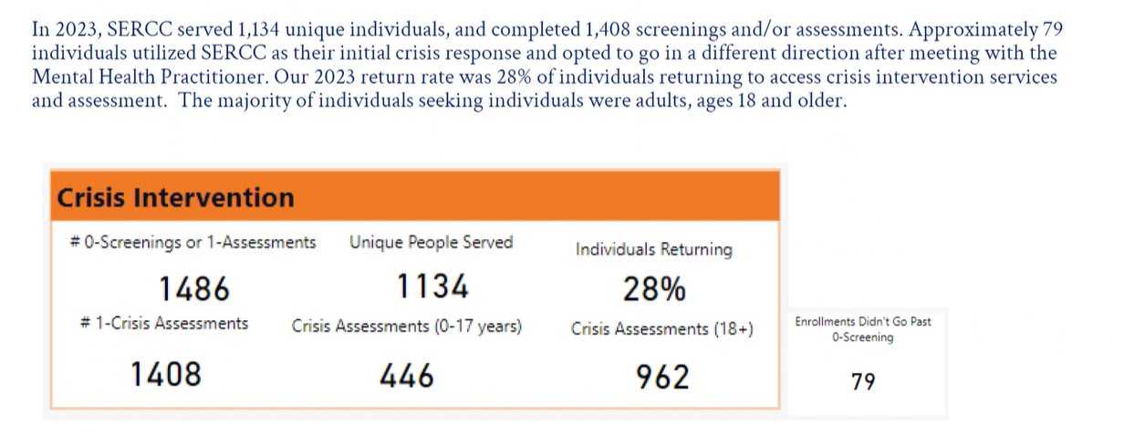

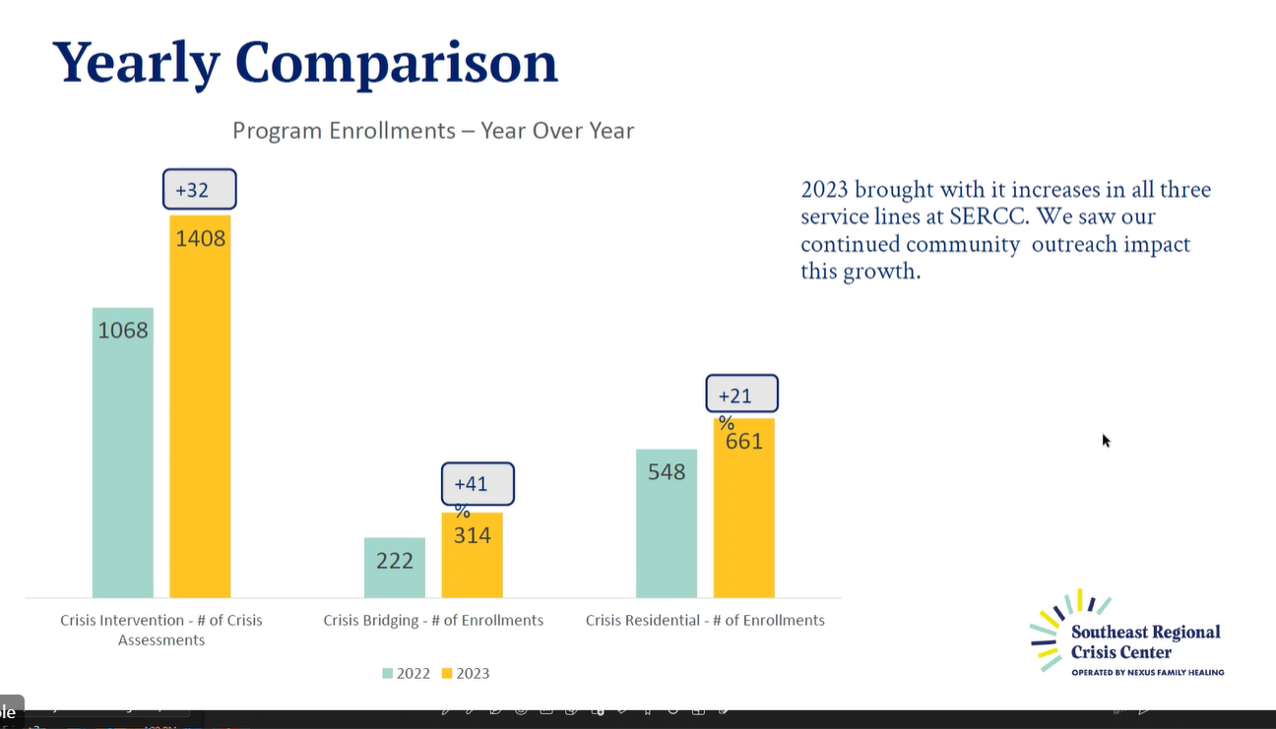

Increase in every service line across all services at SERCC

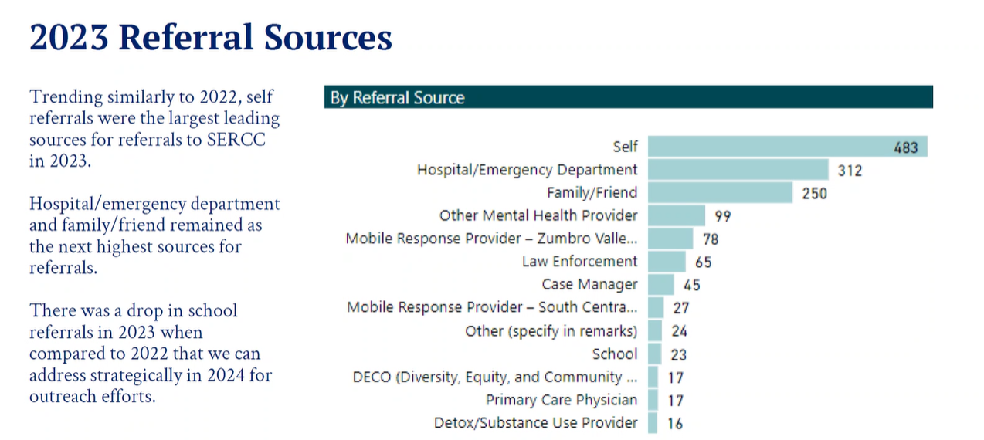

Self Referrals – largest source of referral

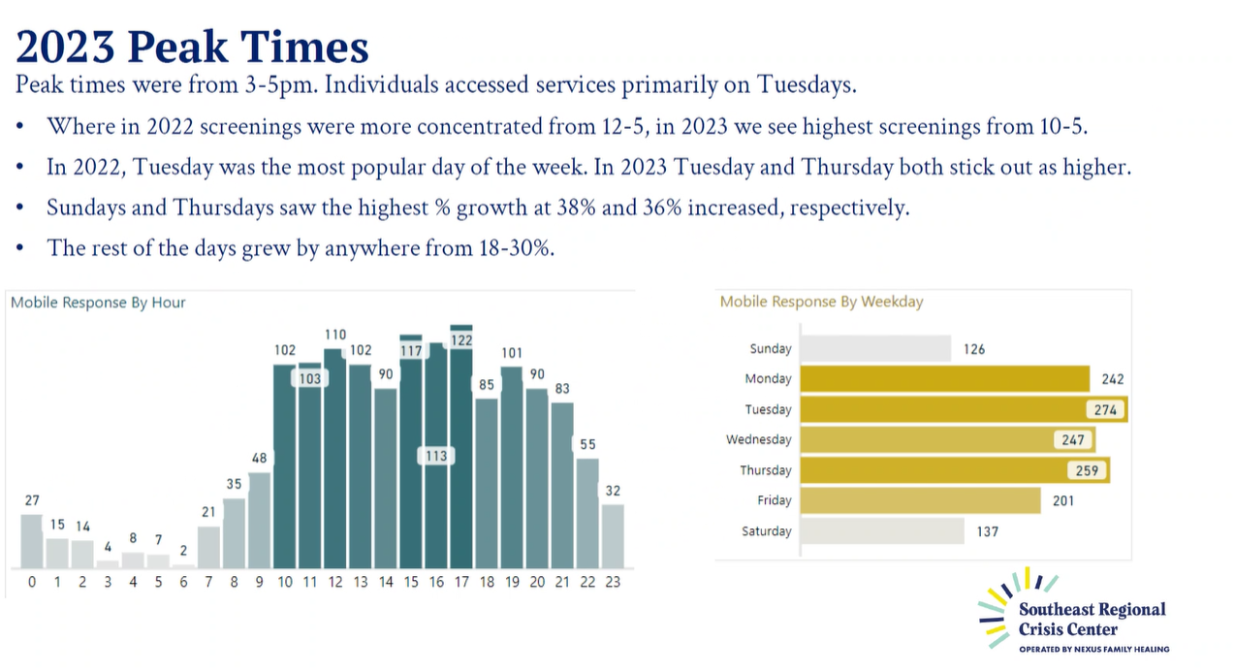

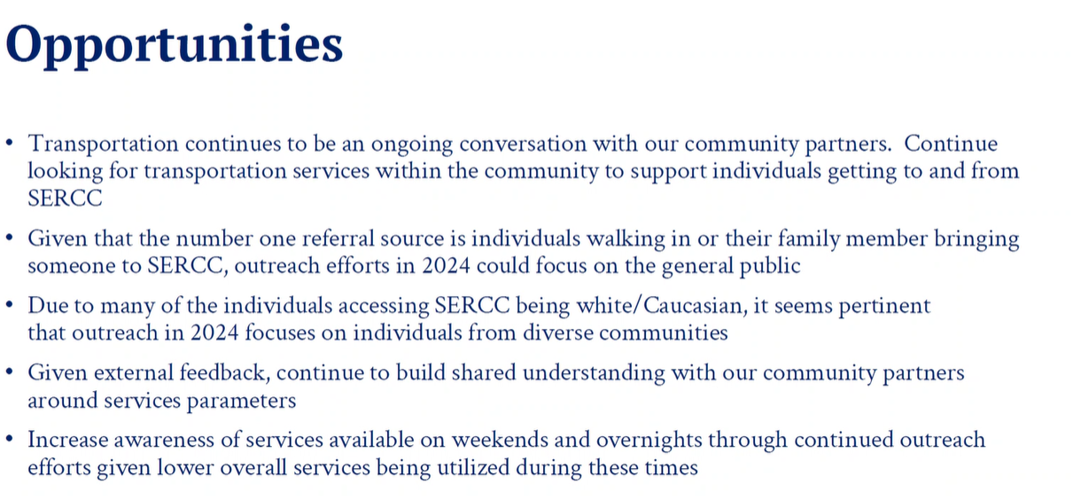

Nina: great work – thank you to all the staff. Every number represents a person who has been helped in a difficult situation.

Dr. Clements – this is phenomenal, with opportunity – outreach with law enforcement for nights/weekends. Not always deco team – outlying counties. Their first thought is ED – please add law enforcement to outreach.

Nicole: yes will continue that outreach.

1. Finance Director’s Report – Mindi Zamzow

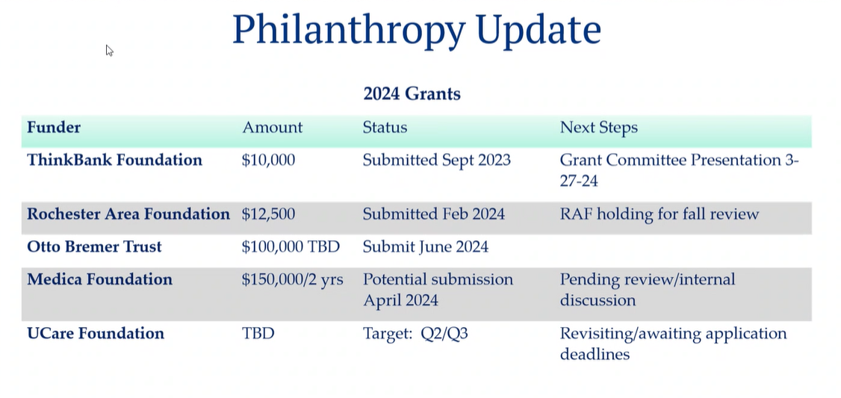

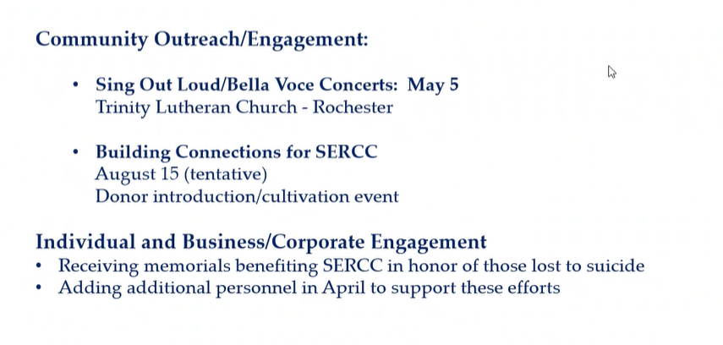





Help identify who should be invited to this event.

Finance Report:

HR Summary – under budget due to open positions

Pledged & Received Report

Braided Funding

Census/Residential Revenue

Actual to Budget for February

Revenue by Source

Expense Comparison

Nina – give overall themes mentioned in Finance Committee. Doing better, cautiously optimistic, etc.?

Mindi – doing well. February net loss decreased compared to January. Braided funding trend down. Uninsured claims – are lower. Nicole: looking at Jan and Feb - $41000 (used 181,000 instead of 222,200 year-to-date) reserve based on year to date for braided funding.2023 was sustainable. Utilizing that methodology into 2024 we are seeing a retainage of braided funding based on what we expected to use is a good sign.

Nicole: brief announcement – Mindi is going to be transitioning within the Nexus

family to another position. We will be hiring for her role. It is in the works – in the interview process for that position. We are excited for Mindi that she gets to grow within Nexus, sad for us here at SERCC and other Nexus agencies she supports. She will stay in her position until we hire and train someone.

Nina: congratulations and thank you for all you have provided for us.

1. Invoicing – Amy Thompson/Meridee Braun
   1. MA requirements. (see above)
2. 2024 Budget Review – Nicole Mucheck – waiting on the Finance Committee – will review at next month’s meeting.
3. Governance Agreement – All
   1. Update SERCC Governance Agreement Discussion Meetings.

Met March 12. Next meeting is scheduled for April 15. Thankful for all who show up and lend their help and wisdom and having robust conversations. Another excellent meeting in March.

From the notes (attached) finished up through the governance agreement at least once. Proposal and recommendation in the works that will be presented in the future.

John: completed a document that presents CREST’s vision. Working with 10 different counties to ID interests, consolidate into a document that addresses and outlines that. Take draft governance language plus that document to the governance work group. Ahead of their next meeting. That committee will work on that draft and bring a recommendation to full SERCC board in not-so-distant future. It may take some time. We are making progress that is sustainable.

Dr. Sutor: how long is the current extension? 30th of June.

1. Annual Report Highlights – Nicole Mucheck (included in Executive Director report above).
2. Adjourn at 4:48

*Next Meeting: April 25, 2024*